Electric House Project- May work with 2 other people.
Project Due Date: May 15, 2014

For this project, you will construct and wire a model house according to the requirements below. Most materials will be provided by Ms. Isabell. You should return any materials left-over to the teacher.

Part A & Part B (construction of the building )should be complete (or close to completion) by May 9th, 2014. On this day, you will be provided with materials to do the wiring. You can come during lunch/Teamtime, etc to get the pieces you need as necessary.
A. The Building
Construct your building in any way you like, as long as it meets these criteria:
- has two rooms connected by a doorway or passage
- structural materials can include but are not limited to: cardboard, foamboard, shoeboxes
- your house must be at least 4” x 6” x 1’ (close to the size of a shoebox)

B. Decorating
Your building is to be decorated neatly and:
- should reflect the purpose of the room (i.e. a refrigerator should not be in a bedroom)
- all inside & outside surfaces of your box (walls, floors, etc.) must be covered
- some kind of 3D objects (tables, chairs, beds, etc) must be present in each room
- you may only use some premade furniture, toys, people, Legos, etc.- By “some” I mean, you should NOT have everything store-bought. I will allow average of one premade item per room. Everything else must be made for this project.

C. The Wiring- will be provided with materials on May 9th, 2014
To earn full credit, each circuit below must be present and working in class:
- A series circuit room: two lights in parallel with each other and in series with two other lights (four lights total) with a switch in one room
- A parallel circuit room: three lights in parallel with a switch in one room
- A single outside light with a switch
Specifics:
- 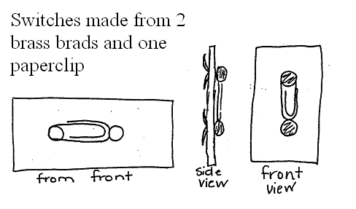Switches can be made from brads and paper clips.
Switches made from 2 brass brads and one paperclip.
- Your house will be powered by a 9V battery so make an obvious two leads to attach your battery to during testing if you do not supply your own battery.
- Each circuit must be able to work independently from the other but both must be able to be on at the same time without moving the battery.
- Insulated wire and lights from holiday lights will be provided.
- You will need access to scissors, wire cutters and wire strippers.

D. The Circuit Diagram
You must provide one diagram for the complete circuit in your building. It must:
- be labeled and be complete including all electrical parts for each circuit
- use accurate circuit symbols- research is needed for this portion
- be neat & drawn with a straight edge ruler
- fill an entire piece of 8.5”x11” paper
- caption (1 paragraph) to describe both parallel and series circuit in your house (how are the loads arranged, how they differ from one another)

